Better B2B

**Release Notes (Aug-Dec 2022)**

**Acumatica Integration**



Published on 27/01/2023

#### Version 3.0

Icon  Description automatically generated 877-536-7486

fusionrms.com

**Contents**

Release Notes Information 3

Acknowledgements 3

Notice 3

New Features and Enhancements 4

Bugs and Issues 5

Fixes 5

UI Changes 6

# Release Notes Information

|  |  |
| --- | --- |
| Software Name | Better B2B |
| Version Number |  |
| Release Type (Initial/Minor/Intermediate/Major) | Major |
| Compatible Acumatica Editions | Retail-Commerce   * 2021 R1 * 2021 R2 |
| Package Location | Product Documentation Site: <https://docs.fusionrms.com/> |

## Acknowledgements

Acumatica 2022 R1, R2, and Acumatica Commerce Edition are registered trademarks of Acumatica Inc. All Rights Reserved.

Customers who use BigCommerce and Acumatica ERP and **are looking** for B2B functionalities that are fully integrated with Acumatica can use BetterB2B as a solution.

The following are some important characteristics:

1. Establishing and managing B2B business, users, roles, and locations effectively
2. Quote Management
3. Management of invoices and payments for Acumatica invoices
4. Salespersons
5. Payment Methods
6. B2B orders and Order management

## Notice

The information contained in this document is subject to change without notice.

Fusion Software LLC shall not be liable for any errors or for incidental or illegal acts in connection with the use of these release notes.

Reproduction, adaptation, or translation of this document is prohibited without prior written permission of Fusion Software, except as allowed under copyright laws. All Rights Reserved.

# New Features and Enhancements

|  |  |
| --- | --- |
| New Feature/Enhancement | Which platform has a new feature/enhancement? |
| Ability to configure Acumatica endpoints with B2B App. | Better B2B |
| Sync master data from Acumatica to B2B app | Better B2B |
| Ability to create and manage role specific user account | Better B2B |
| Ability to sync: customers, sales orders and products | Better B2B |
| Admin user can now click on ‘company name’ and edit all details in Big Commerce using B2B app | Better B2B |
| Sync customized connector with modified customer records from Acumatica to B2BApp if the customer type is B2B. | Better B2B |
| Ability to sync the modified admin User account data of B2BApp to Acumatica's Primary Contact based on the Acumatica 'Contact id' preserved in both Acumatica and B2BApp. | Better B2B |
| Based on the field mapper, the customizable connector can now be in sync with the Customer location/Company location & Contact addresses (on create & edit) between Acumatica & B2BApp (bi-directionally). | Better B2B |
| A checkbox is required that allows (if enabled) store admin users / normal users to make an order quickly by clicking on a link that must be displayed on the top right navigation of the BigCommerce website to easily place an order by inserting / uploading a single / multiple product name / SKU. | Better B2B |
| Queues management: Ability to configure Acumatica queues in B2B App and sync all entities between Acumatica and B2BApp in the form of queues. - Management of Queues | Better B2B |
| Quotes - Ability to sync quotes (Order Templates = QT) from Acumatica to B2BApp and vice - versa. Quotes are created as Sales Order 'QT' in Acumatica. | Acumatica |
| Invoices – Ability to sync open, balanced, and closed bills from Acumatica to B2BApp and allow users to pay for open and balanced invoices. | Better B2B |

# Bugs and Issues

There are no known bugs or issues.

# Fixes

* A bug was fixed for payouts that should not be displayed on the invoices (Batch process) screen when payments are made in Acumatica before syncing to B2B.
* A bug was fixed for invoices that did not sync on Open and Closed statuses.
* A bug was fixed for "Record cannot be saved" error message appeared while Invoice sync is performed.
* A bug was fixed when an object reference error was displayed during the invoice sync. • A bug was fixed when 404 Not Found was displayed on the front end site under "INVOICES" Tab.
* A bug was fixed where Payment date is displayed incorrectly on the B2B app while using PAYPAL.
* A bug was fixed where Sales staff user is not deleted even after clicking on delete option.
* A bug was fixed where Permissions are incorrectly displayed when a new role is created in Frontend store.
* A bug was fixed for Invoice Payment; upon clicking on pay, loading icon not being displayed on storefront.
* A bug was fixed on the Acumatica Connection Failed Issue when syncing from B2B to Acumatica.

# UI Changes

Configuring Acumatica endpoints in B2B app.

Quotes are created in Acumatica as Sales Order ‘QT’  
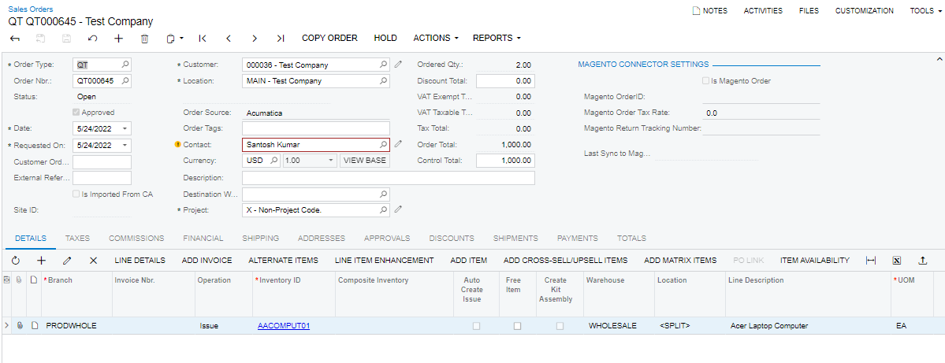  
**Installation Changes**

There are no installation changes in this release.